**Festival in Christiana**

This work is inspired by Xenakis’s stochastic synthesis, which was the so-called creation of a new form in music. I have read a few of books and articles, such as *Formalized Music* by Xenakis and *Iannis Xenakis’s “Achorripsis”: The Matrix Game* by Linda M. Arsenault, to understand how the technique was used. The title of the work is inspired by a visit to Christiana, Copenhagen. Christiana is known as a cannabis market by the locals, in which you are not allowed to shout or use your phones in, and it has many areas with different themes. Thus, I found Christiana was related to my work; each column has its own colour in dynamics, timbres and atmosphere.

I chose 30 columns (units of time; five bars in each column), 9 rows (musical timbres) and λ = 0.7 as the mean density of events for the work. With the implication of Poisson’s formula, I obtained the table of probabilities and then multiplied those probabilities by the number of total events (30 Columns x 9 Rows = 270 events), which resulted in a distribution of 136 zero events, 92 single events, 33 double events, 8 triple events, and 1 quadruple event. As we know zero events represent silence, however, I used air sound for aesthetic reasons instead of simply having silence. To distribute the events among the columns, I had to calculate the total number for each kind of event for columns (which were 136, 92, 33, 8, 1) and divide by the number of columns (30), to get the new value of λ for each kind of event. The new values of λ are zero event= 4.467, single event = 3.133, double event = 1.1, triple event = 0.25, and quadruple event = 0.05. Once we obtained each new value of λ, the calculation was repeated as done before but this time it was multiplied by the number of columns (probabilities x 30 Columns). However, I did not follow the numbers obtained by the strict application of Poisson’s formula and adjusted some numbers slightly.

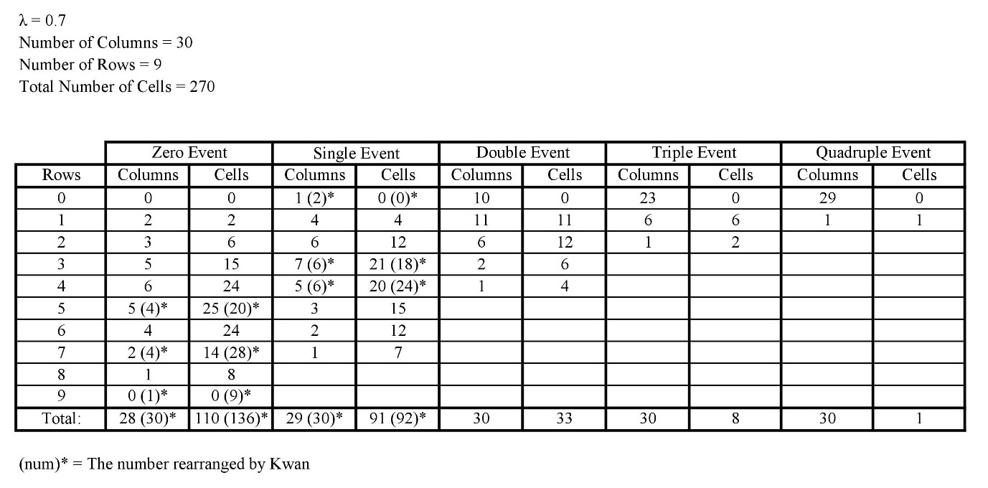

After all the calculations were done, I randomly chose to arrange the 270 events (distribution of zero, single, double… events) in a matrix consisting of 30 columns and 9 rows.

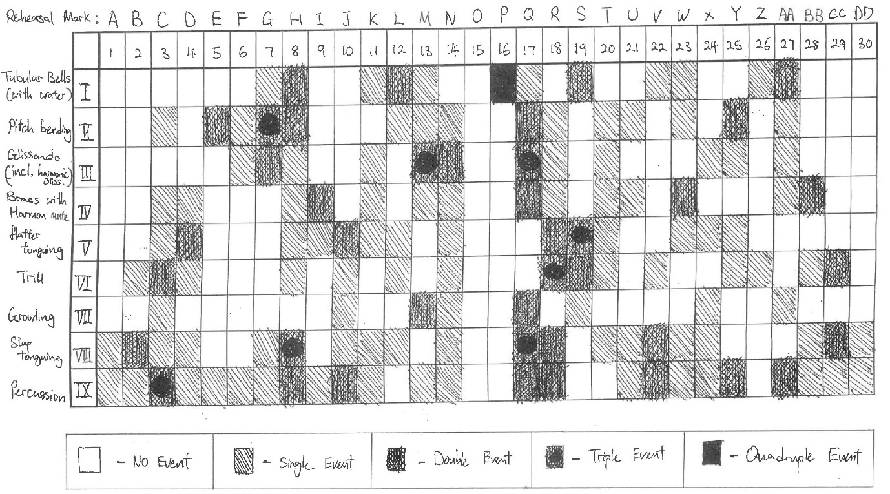

As we can see from the matrix, the 9 musical timbres that I used are tubular bells with a bucket of water, pitch bending, glissando (including harmonic glissando), brass with harmon mute, flutter tonguing, trill, growling, slap tonguing, and percussions (Bongos, Anvil, Medium Wood Block, and Kick Drum). Furthermore, these musical timbres were also calculated precisely. For example, I have 10 Tubular Bells with water, 30 pitch bending, 10 glissando, 25 brass with harmon mute, 20 flutter tonguing, 30 trill, 10 growling, 50 slap tonguing and 30 percussion events occuring in a single event, then in a double event, these quantities are doubled and so on. These musical timbres are always altered and played among the instruments to explore and create different timbres.

On the other hand, with the idea that everything has two sides, I discovered zero events are very different from other events; zero events have no pitch. Hence, air sound is applied to represent the “nothingness” of zero events as power from another side. Also, zero events are in every column just like the air is everywhere, sometimes it is weak but sometimes it is strong. For example, I left Column 15 for zero events to show the power of “nothingness”.

To create a free atonal sound world, the pitch material is mainly based on twelve -tones series and dissonant-intervallic approaches, such as minor/major 9th, minor/major 7th and tritones. The work applies two sets of twelve-tone rows, which are A–G–C#–E–C–B–G#–D–A#–D#–F–F# and C#–D–A#–B–F–E–D#–A–G#–C–G–F#. However, it does not follow the strict traditional rules of serialism. I made a matrix based on the row, then allowed myself to begin and move anywhere in the matrix.

Furthermore, slap tonguing represents the sound of rainfall, but it is difficult to mimic the randomness of the rain. Therefore, the quintuplets, and triplets in simple time grouping is used to achieve the rhythm of randomness. However, it was too demanding for the ensemble to read and play. So, I decided to hide all the rests and tuplets, then relied on space reading for performance. The examples below show the difference with and without tuplets and rests.

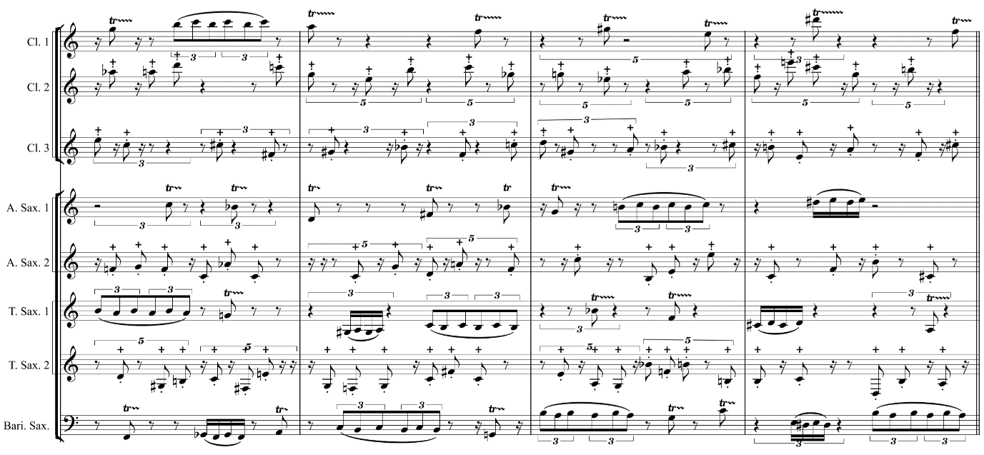

Figure 1: Example of with tuplets and rests from column 18

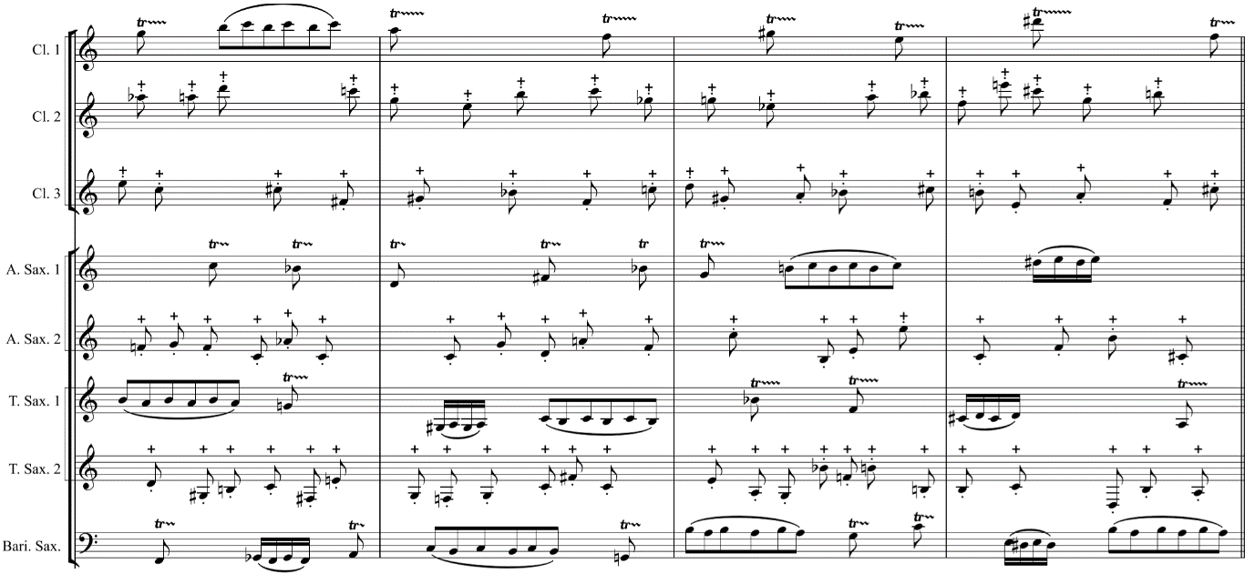

Figure 2: Example of without tuplets and rests from column 18

In addition, the conductor will conduct five beats in each column and the ensemble will estimate individually when they are playing.